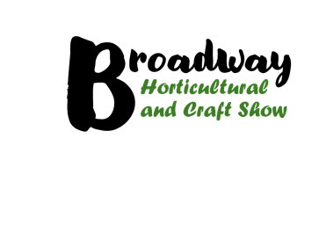
Broadway Autumn show booking form

Business name

Contact name

Business address

Post code

Contact phone number

Email

Social Media details

Product Description (all items must be hand made by you in a true “Craft method)

Do you supply the village? If so who/where

Please send public liability insurance details

Return entry form by April 30th 2026

Commercial stall cost - £50 for a 3m x 3m space

Charity stall cost - £25 for a 3m x 3m space

Please email your completed form to jayne.insley@outlook.com.

Once we confirm your application an invoice will be sent with payment to be made by July 31st 2026.

